HOSPITAL MANAGEMENT SYSTEM

Use Case Document


 | Prepared By | Last Updated By | Reviewed by 1 | Reviewed by 2 | Approved By
Name | Charu Dhingra | Lucky Sharma | Abhinav Kumar | Dhanakshi Jain | Divanshu Sharma
Role | Team Member | Team Member | Team Member | Team Member | Scrum Master
Signature
Date | April 12,2019 | April 12,2019 | April 12,2019 | April 12,2019 | April 12,2019

Table of Contents
1.0 Introduction 3
1.1 Purpose & Scope of the document 3
1.2 Intended Audience 3
1.3 Use case ‘Admin Registration’ 3
1.3.1 Use case attributes 3
1.3.2 Use Case Model 4
1.3.3 Business Rules 4
1.3.4 UI Requirements 5
1.3.5 UI Field Validations 5
1.4 Use case ‘Admin Credential Authentication’ 6
1.4.1 Use case attributes 6
1.4.2 Use Case Model 7
1.4.3 Business Rules 7
1.4.4 UI Requirements 7
1.5 Use case ‘Patient Registration’ 8
1.5.1 Use case attributes 8
1.5.2 UI Field Validations 9
1.5.3 UI Requirements 9
1.6 Use case ‘Physician Registration’ 10
1.6.1 Use case attributes 10
1.6.2 UI Field Validations 11
1.6.3 UI Requirements 11
1.7 Use case ‘Patient Diagnosis Details’ 11
1.7.1 Use case attributes 11
1.8 Use case ‘Admin Logout’ 12
1.8.1 Use case attributes 12
2.0 Database Design 13
2.1 Tables Structure 13
3.0 Change Log 16

Introduction

Purpose & Scope of the document
The purpose of this Use case document is to systematically capture requirements for the project and the system to be developed in terms of use cases. Functional use cases are captured in this document. It also serves as the input for the project scoping.

The scope of this document is limited to addressing the use cases from a user, quality, and non-functional perspective.

Intended Audience
Each member of the project team

Use case ‘Admin Registration’

Use case attributes
Use Case Description:

This use case deals with the capture of admin details. The ‘admin’ here shall be the operator of the system and will be keying in the patient information into the system.

Scope:

- Admin registration

Actors:

- Admin – the operator

Trigger:

Click ‘Submit’ button in the ‘Admin Registration’ page

Pre-Condition:

Admin being able to access the homepage & get redirected to the ‘Admin Registration’ page upon click of ‘Register if new’ link.

Post Condition:

Admin is in the enrollment page & submit details

Flow of Events:

User at homepage → Click ‘Register if new’ link → Admin is in the enrollment page → Admin details are submitted and added onto the database

Primary Scenario:
A new user – is able to click ‘Register if new’ link and able to provide his details and get enrolled in the system.

Use Case Model
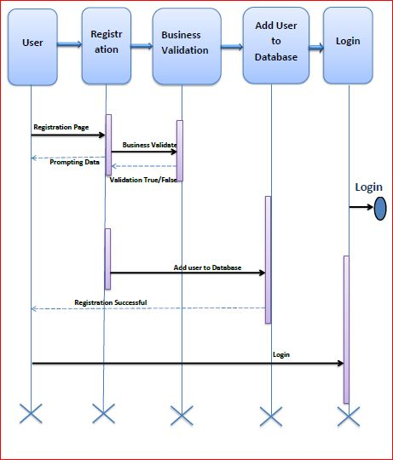

Business Rules

Business rules should be defined using the following attributes: -

- When the admin clicks on the registration link, it should re-direct to registration form.
    - Admin needs to fill some of the basic attributes/fields as mentioned below in requirement: First Name, Last Name, Age, Gender, Contact Number, Password
- Clicking ‘Submit’ should validate the datatype constraints for each field
- Post-successful field level validation, save the information in the database
- Upon saving the information in the database, display the message ‘Your details are submitted successfully and your id is AdminId’.

UI Requirements
Here is a prototype on how the homepage should look like.



Here is a prototype on how the ‘User Registration’ page should look like.

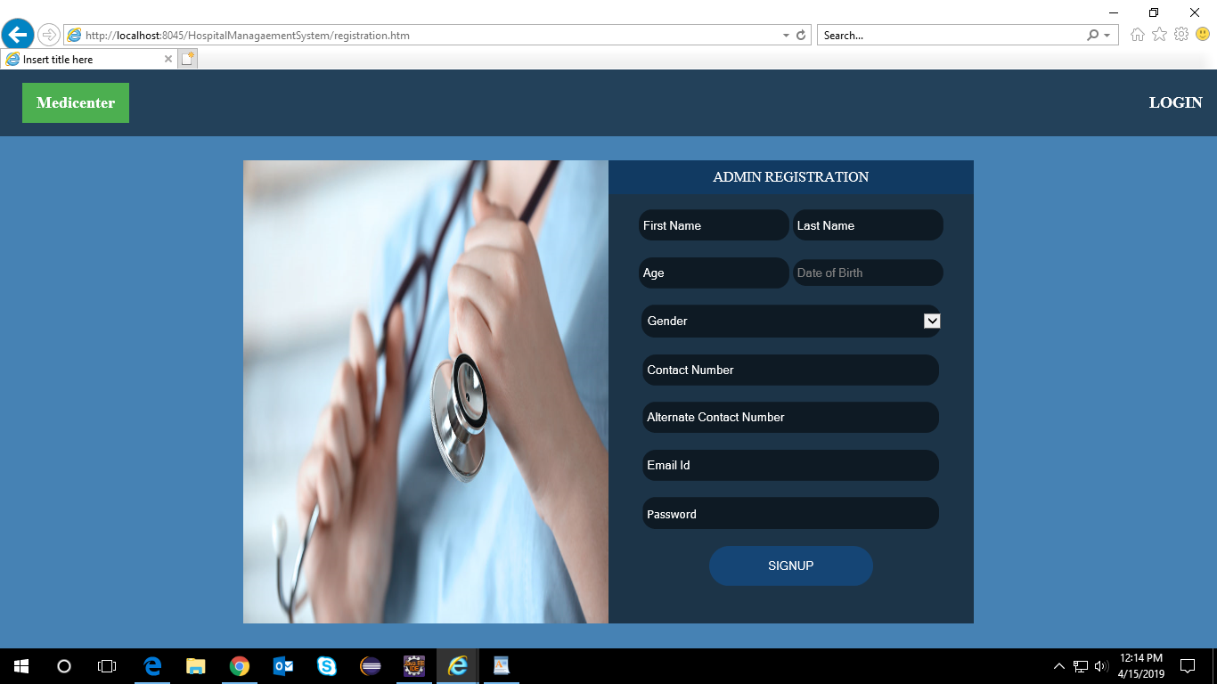

UI Field Validations
Please refer to the below requirements for field level validations:

- All fields are mandatory.
- Password should have minimum 8 chars, no space & can contain special characters (ex.! ,@,#,%, *,& etc.)
- Password and Confirm Password fields should be the same
- The Email ID format must be checked. (For ex. test@testmail.com.)
- Phone Number must be of 10 digits’ length

Use case ‘Admin Credential Authentication’

Use case attributes
Use Case Description:

This use case deals with the authentication of the user credentials. The ‘user’ here shall be the operator of the system and will be keying in the patient information into the system.

Scope:

- Admin credentials authentication

Actors:

Admin – the operator

Trigger:

Click ‘Login’ link, after keying in ‘AdminID’ & ‘Password’ field.

Pre-Condition:

Admin being able to access the homepage

Post Condition:

Admin is in the Admin Registration page

Flow of Events:

User at homepage → Key in ‘AdminID’ & ‘Password’ field → Admin credentials are validated → Patient Registration page is displayed

Primary Scenario:
A registered user – is able click ‘Login’ link, after keying in ‘AdminID’ & ‘Password’ field and get his credentials authenticated with the existing database entry.

Alternative Scenario:
A registered user – is able click ‘Login’ link, after keying in ‘AdminID’ & ‘Password’ field and unable to get his credentials authenticated. The user is presented with relevant error messages:

- Invalid Admin ID – ‘The adminId provided does not exist in our records’
- Incorrect Password – ‘Password provided is incorrect. Please reach out to your system

Use Case Model

Business Rules
Business rules should be defined using the following attributes:-

- A registered admin – is able click ‘Login’ link, after keying in ‘AdminID’ & ‘Password’ field and get his credentials authenticated with the existing database entry.

UI Requirements
Here is a prototype on how the patient registration should look like.

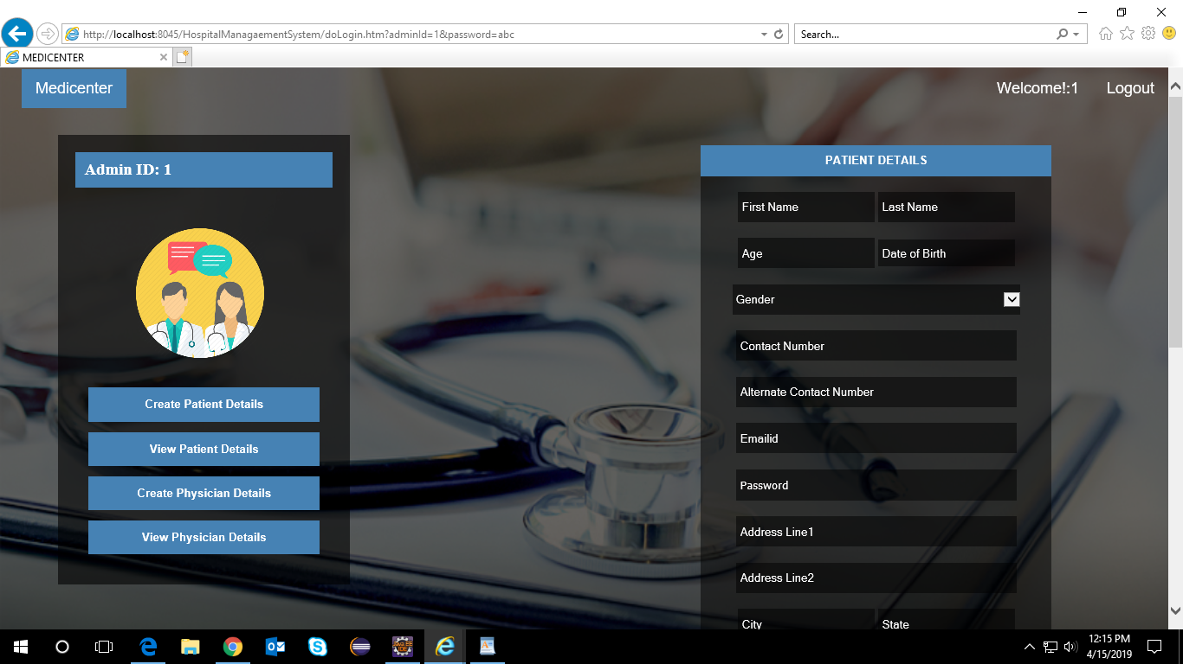

Use case ‘Patient Registration’

Use case attributes
Use Case Description:

This use case deals with the capture of patient details. The ‘admin’ here shall be the operator of the system and will be keying in the patient information into the system.

Scope:

- Patient registration

Actors:

- Admin – the operator

Trigger:

Click ‘Submit’ button in the ‘Patient Registration’ page

Pre-Condition:

Admin being able to access the homepage & get redirected to the ‘Patient Registration’ page upon click of ‘Register new Patient’ link.

Post Condition:

Admin is in the enrollment page & submit details

Flow of Events:

Admin at homepage → Click ‘Register new Patient’ link → Admin is in the patient enrollment page → Patient details are submitted and added onto the database

Primary Scenario:
Admin – is able to click ‘Register if new patient’ link and able to provide his details and get enrolled in the system.

Alternative Scenario:
A registered Admin – is able click ‘Submit’ link, after keying in all the patient details field and unable to get the patient registered. The Admin is presented with relevant error messages.

UI Field Validations

Please refer to the below requirements for field level validations:

- All fields are mandatory.
- Password should have minimum 8 chars, no space & can contain special characters (ex.!, @,#,%,*,& etc.)
- Password and Confirm Password fields should be the same
- The Email ID format must be checked. (For ex. test@testmail.com.)
- Phone Number must be of 10 digits’ length

UI Requirements
Here is a prototype on how the patient registration should look like.

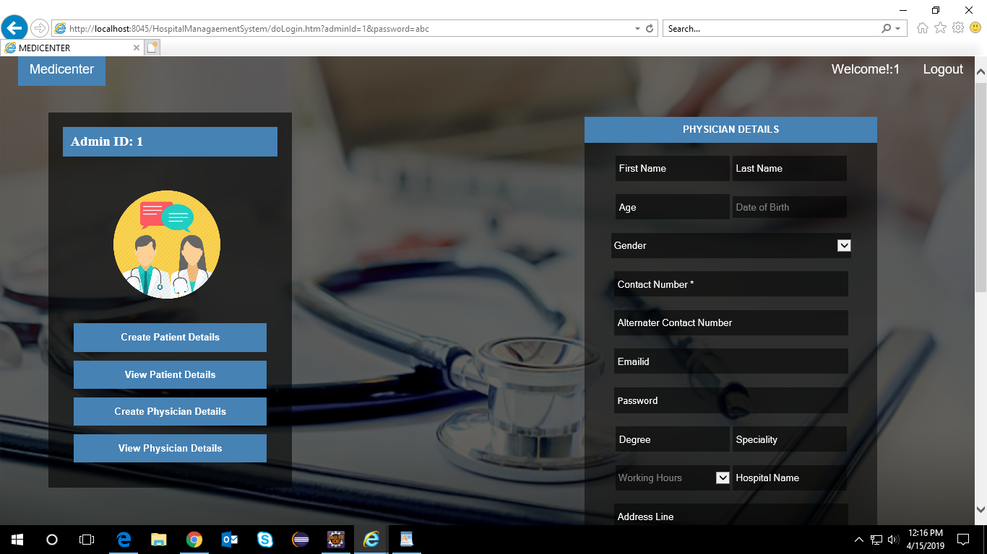

Use case ‘Physician Registration’

Use case attributes
Use Case Description:

This use case deals with the capture of physician details. The ‘admin’ here shall be the operator of the system and will be keying in the physician information into the system.

Scope:

- Physician registration

Actors:

- Admin – the operator

Trigger:

Click ‘Submit’ button in the ‘Patient Registration’ page

Pre-Condition:

Admin being able to access the homepage & get redirected to the ‘Physician Registration’ page upon click of ‘Register new Physician’ link.

Post Condition:

Admin is in the enrollment page & submit details

Flow of Events:

Admin at homepage → Click ‘Register new Physician’ link → Admin is in the physician enrollment page → Physician details are submitted and added onto the database

Primary Scenario:
Admin – is able to click ‘Register if new physician’ link and able to provide his details and get enrolled in the system.

Alternative Scenario:
A registered Admin – is able click ‘Submit’ link, after keying in all the patient details field and unable to get the physician registered. The Admin is presented with relevant error messages.

UI Field Validations

Please refer to the below requirements for field level validations:

- All fields are mandatory.
- Password should have minimum 8 chars, no space & can contain special characters (ex.! , @,#,%,*,& etc.)
- Password and Confirm Password fields should be the same
- The Email ID format must be checked. (For ex. test@testmail.com.)
- Phone Number must be of 10 digits’ length

UI Requirements
Here is a prototype on how the patient diagnosis registration should look like.

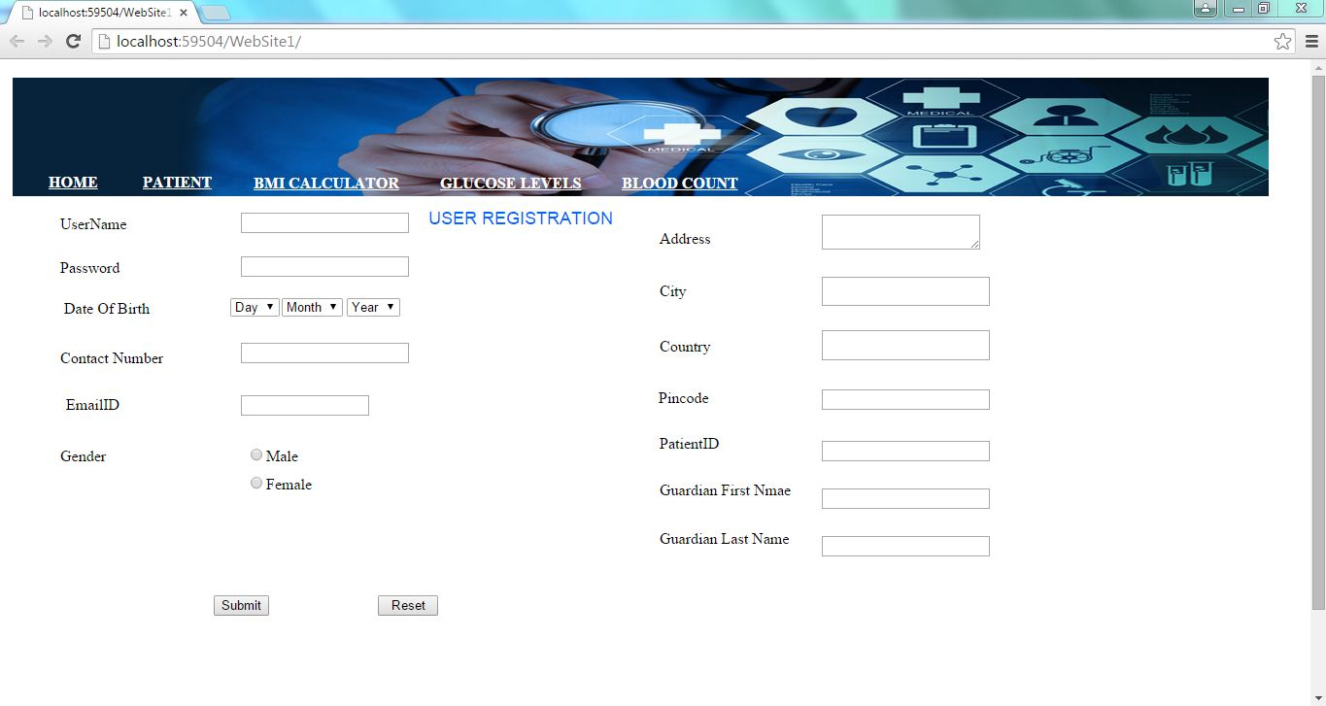

Use case ‘Patient Diagnosis Details’

Use case attributes
Use Case Description:

This use case deals with the capture of patient diagnosis details. The ‘admin’ here shall be the operator of the system and will be keying in the patient diagnosis information into the system.

Scope:

- Patient Diagnosis Details

Actors:

- Admin – the operator

Trigger:

Click ‘Submit’ button in the ‘Patient Diagnosis Details’ page

Pre-Condition:

Admin being able to access the homepage & get redirected to the ‘Patient Diagnosis Details’ page upon click of ‘Add Patient Diagnosis Detail’ link.

Post Condition:

Admin is in the enrollment page & submit details

Flow of Events:

Admin at homepage → Click ‘Add Patient Diagnosis Details’ link → Admin is in the patient diagnosis page → Patient diagnosis details are submitted and added onto the database

Primary Scenario:
Admin – is able to click ‘Register if new patient’ link and able to provide his details and get enrolled in the system.

Alternative Scenario:
A registered Admin – is able click ‘Submit’ link, after keying in all the patient details field and unable to get the patient registered. The Admin is presented with relevant error messages.

Use case ‘Admin Logout’

Use case attributes
Use Case Description:

When Admin Click on the Logout button the Admin will be logged out and the session for the admin will be over for that time until the again Login of Admin.

Database Design

Tables Structure
Admin Registration:
Column Name | Data Type | Length | Nulls
Admin Id | Varchar | 50 | N
First Name | Varchar | 50 | N
Last Name | varchar | 50 | N
Age | Int | 5 | N
Gender | Varchar | 10 | N
Date of Birth | Date | 50 | N
Contact Number | Varchar | 10 | N
Alt Contact Number | Varchar | 10 | N
Email | Varchar | 50 | N
Password | Varchar | 50 | N

Patient:
Column Name | Data Type | Length | Nulls
Patient Id | Varchar | 10 | N
Firstname | Varchar | 50 | N
Lastname | Varchar | 50 | N
Age | Varchar | 2 | N
Gender | Varchar | 2 | N
Date Of Birth | Date | 30 | N
Contact Number | Varchar | 10 | N
Alt Contact Number | Varchar | 10 | N
Email | Varchar | 50 | N
Password | Varchar | 20 | N
Address Line 1 | Varchar | 250 | N
Address Line 2 | Varchar | 250 | N
City | Varchar | 50 | N
State | Varchar | 20 | N
Zipcode | varchar | 10 | N

Physician:
Column Name | Data Type | Length | Nulls
Physician Id | Varchar | 10 | N
Firstname | Varchar | 50 | N
Lastname | Varchar | 50 | N
Age | Varchar | 2 | N
Gender | Varchar | 2 | N
Date Of Birth | Date | 30 | N
Contact Number | Varchar | 10 | N
Alt Contact Number | Varchar | 10 | N
Email | Varchar | 50 | N
Password | Varchar | 20 | N
Address Line 1 | Varchar | 250 | N
Address Line 2 | Varchar | 250 | N
City | Varchar | 50 | N
State | Varchar | 20 | N
Zipcode | Varchar | 10 | N
Degree | Varchar | 50 | N
Speciality | Varchar | 50 | N
Work Hours | Varchar | 50 | N
Hospital Name | Varchar | 100 | N

Patient Diagnosis Details:
Column Name | Data Type | Length | Nulls
Report Id | Number | 10 | N
Patient Id | Varchar | 50 | N
Physician Id | Varchar | 50 | N
Service Date | Date | 20 | N
Test Result Date | Date | 20 | N
Date Of Birth | Date | 30 | N
Blood_WBC_AR | Varchar | 20 | N
Blood_WBC_NR | Varchar | 20 | N
Blood_RBC_AR | Varchar | 20 | N
Blood_RBC_NR | Varchar | 20 | N
Blood_HGB_AR | Varchar | 20 | N
Blood_HGB_NR | Varchar | 20 | N
Blood_HCT_AR | Varchar | 20 | N
Blood_HCT_NR | Varchar | 20 | N
Blood_MVC_AR | Varchar | 20 | N
Blood_MVC_NR | Varchar | 20 | N
Blood_MCH_AR | Varchar | 20 | N
Blood_MCH_NR | Varchar | 20 | N
Blood_MCHC_AR | Varchar | 20 | N
Blood_MCHC_NR | Varchar | 20 | N
Physician Comments | Varchar | 250 | N
Other Info | Varchar | 100 | N

Change Log
Version Number | Changes Made
V1.0 | Initial baseline created on <12-04-19> by <Divanshu Sharma>
V1.1 | <Please refer the configuration control tool / change item status form if the details of changes are maintained separately. If not, the template given below needs to be followed>
V1.1 | Section No. | Changed By | Effective Date | Changes Effected
V1.1 | NONE | NONE | NONE | NONE

